**Exercise 7: Online Bookstore - Introduction to Data Transfer Objects (DTOs)**

Business Scenario:

Use DTOs to transfer data between the client and server for books and customers.

1. **Create DTOs:**

* I defined BookDTO and CustomerDTO classes.

BookDTO:

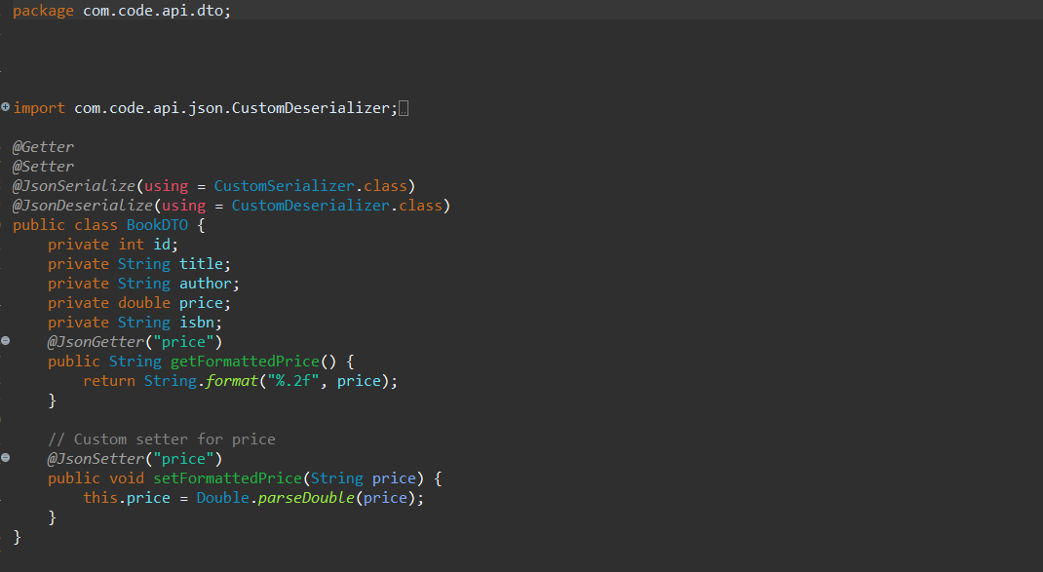

CustomerDTO:

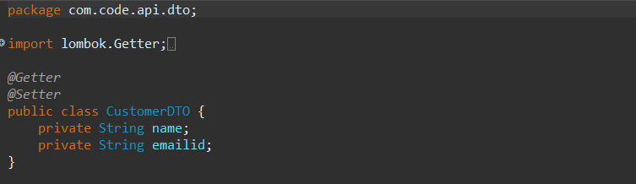

1. Mapping Entities to DTOs:

* I used ModelMapper library to map entities to DTOs and vice versa:

Initially, in the pom.xml file I addded the modelmapper dependency:

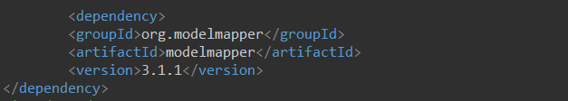

Now I used the ModelMapper library in the service class:

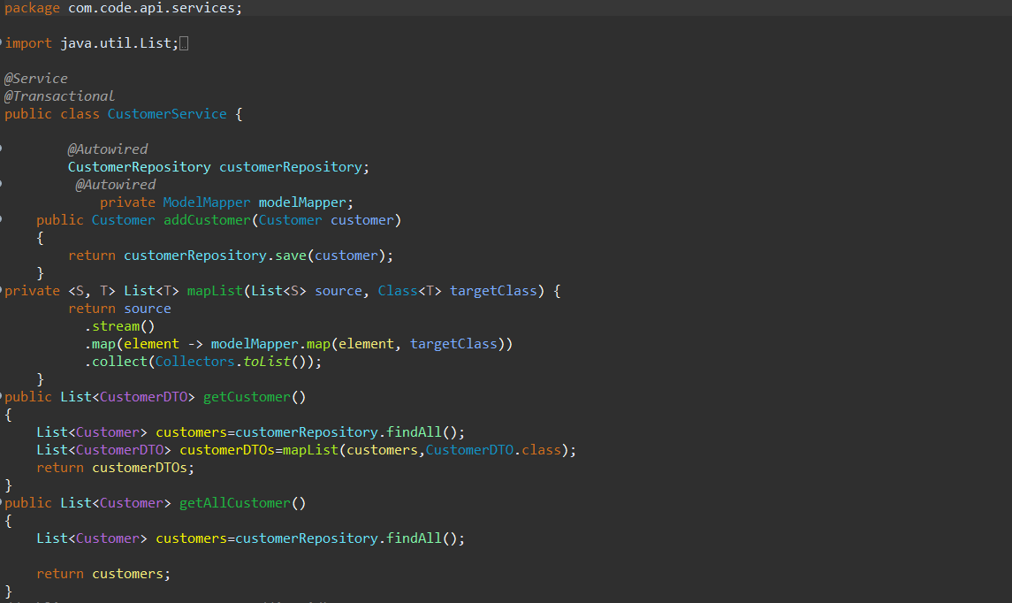

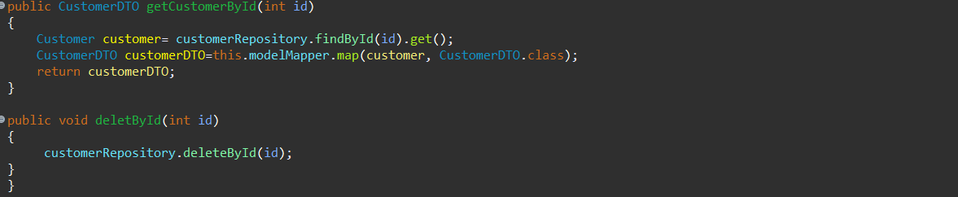

1. Custom Serialization/Deserialization:

* I Customized JSON serialization and deserialization using Jackson annotations

I created a package named “com.code.api.json” and under that I created two classes namely, CustomSerializer and CustomDesializer.

Serialize: converting object into byte

Deserialize: converting byte into object

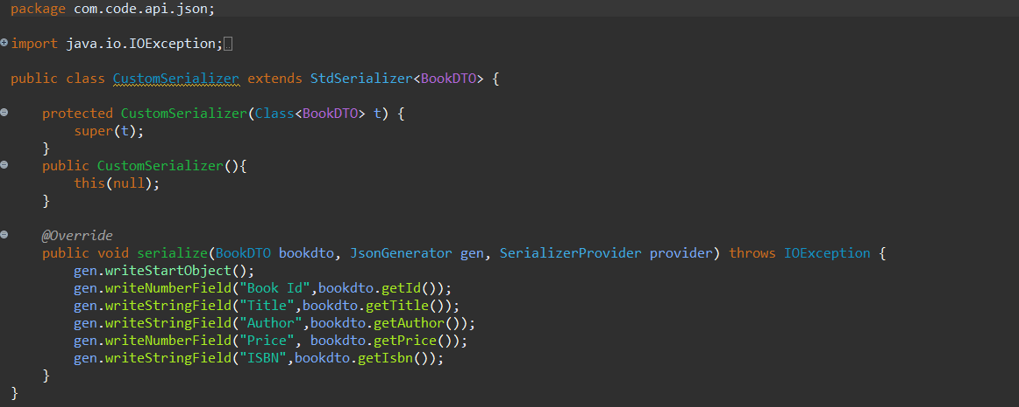

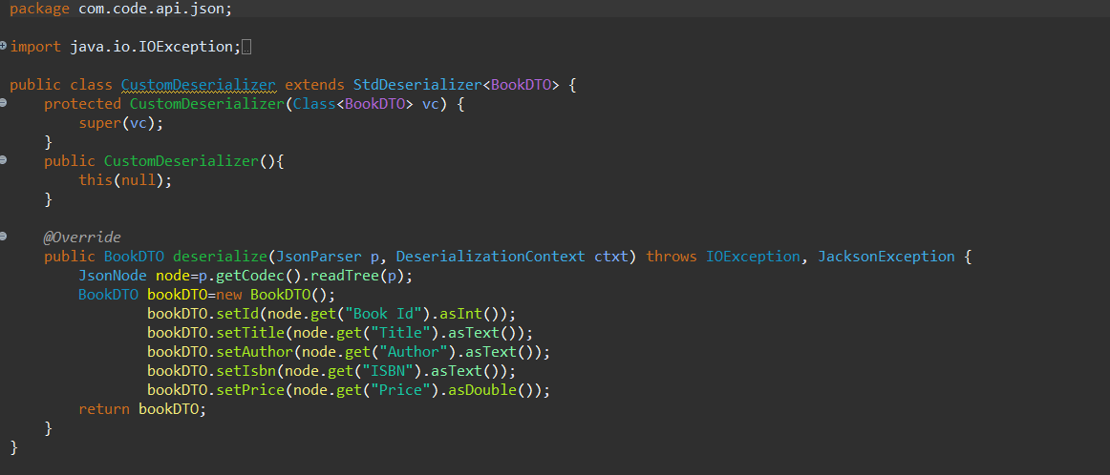

The Jackson annotations have been already used in the BookDTO class:

@JsonSerialize

@JsonDesrialize

@JsonGetter

@JsonSetter



**Output:**

